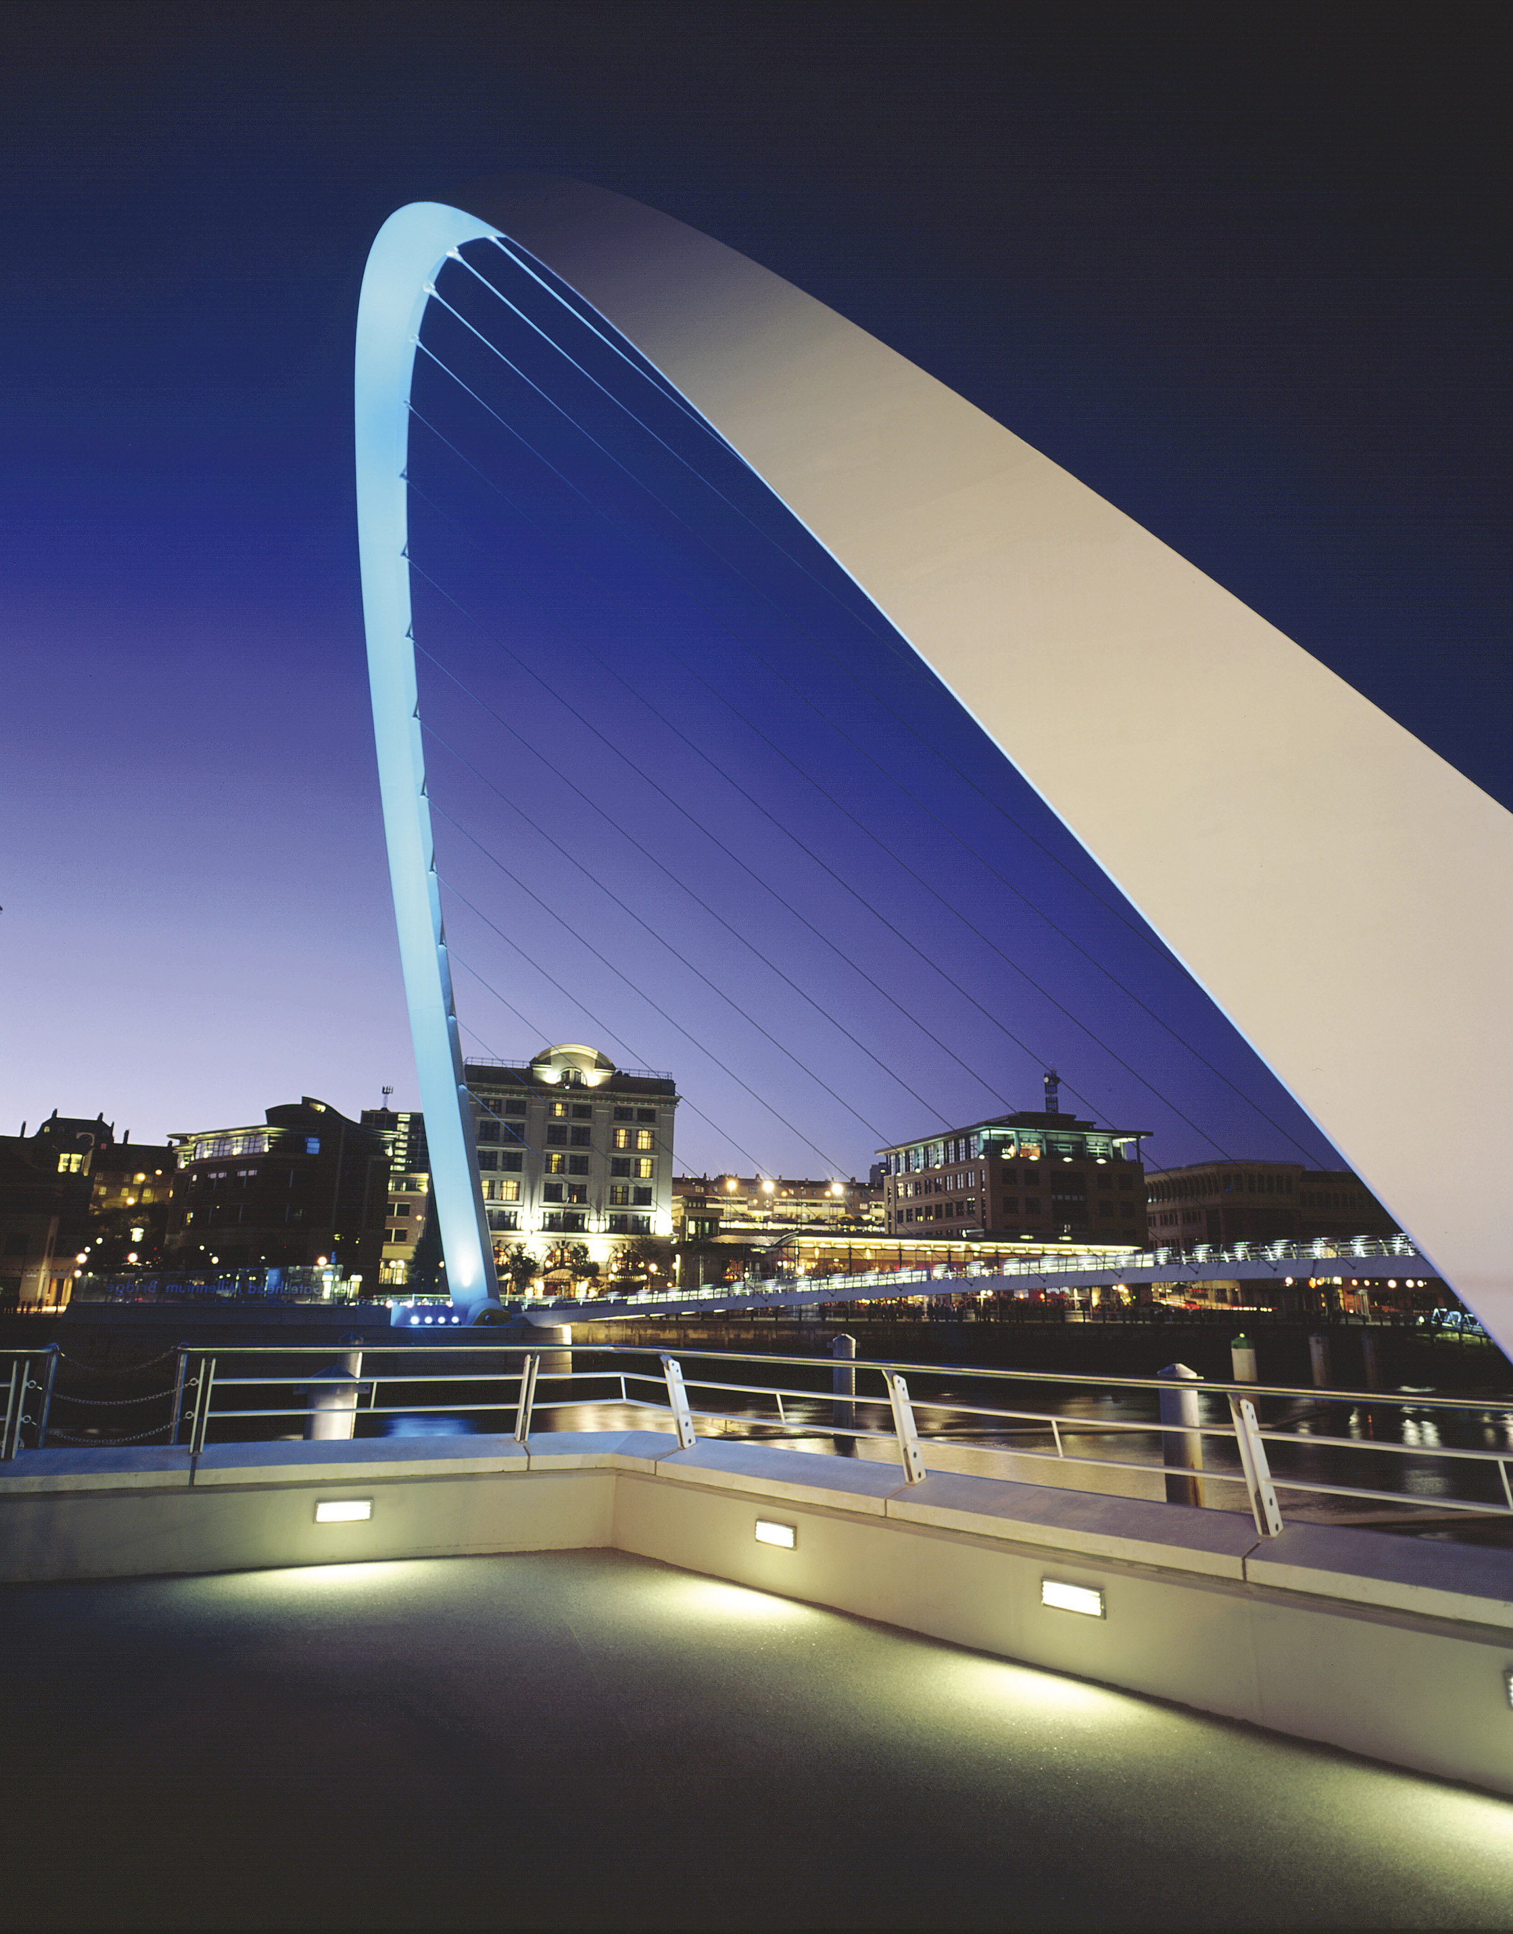
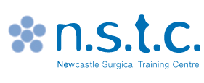
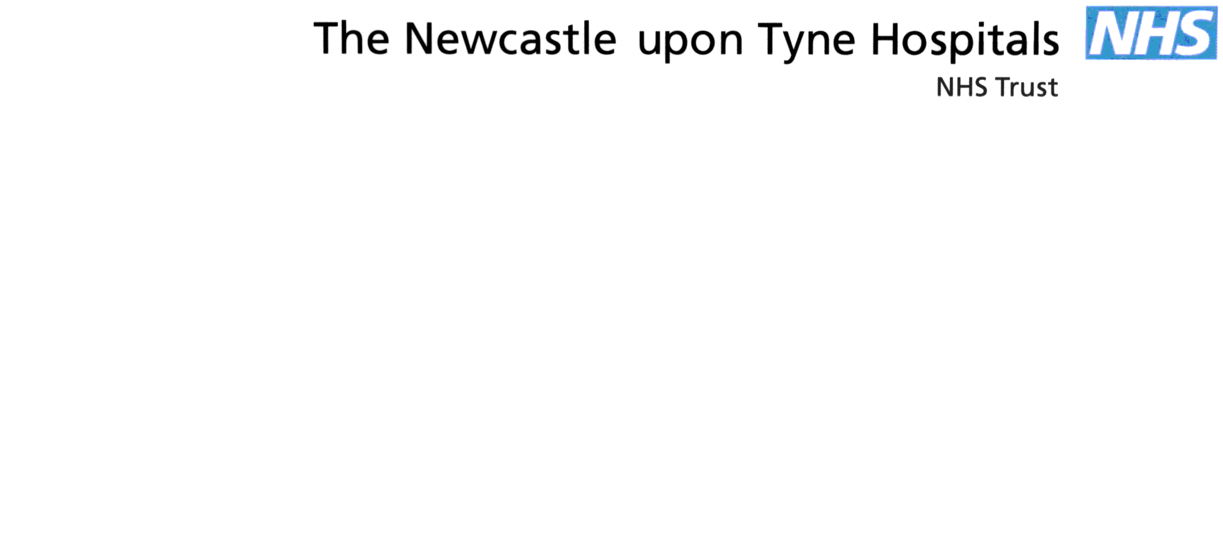

NEWCASTLE SURGICAL
TRAINING CENTRE


Pituitary Gland Surgery Course
21st May 2015 mergency Surgery course (ACTS)

FACULTY
mergency Surgery course (ACTS)

Mr Sean Carrie | Consultant ENT Surgeon, Newcastle upon Tyne NHS Trust
Alistair Jenkins | Consultant Neurosurgeon, Newcastle upon Tyne Hospitals NHS Trust
John Hill | Consultant ENT Surgeon, Newcastle upon Tyne Hospitals NHS Trust
Claire Nicholson | Consultant Neurosurgeon, Newcastle upon Tyne Hospitals NHS Trust
Mr Saurabh Sinha | Consultant Neurosurgeon, Royal Hallamshire Hospital, Sheffield
Mr Alex Paluzzi | Consultant Neurosurgeon, Queen Elizabeth Hospital, Birmingham

Pituitary Gland Surgery Course
mergency Surgery course (ACTS)

08.30 - 08.45 | Registration & Refreshments
08:45 – 09.05 | Endoscopic Surgical Anatomy and Approaches to Sphenoid sinus and fossa | Sean Carrie / John Hill
09.05- 9:40 | Sella & Parasella : Pathology and Surgical Management | Saurabh Sinha
09.40- 10.15 | Extended Endoscopic Skull Base Approaches | Alex Paluzzi
10:15 – 10:30 | Refreshments NSTC COFFEE AREA
10.30- 12.15 | Practical Session: Endoscopic approach to Skull Base | Wet Lab /All Faculty
12.15 – 13:15 | Working Lunch  Clinical Cases: Discussion & Controversies Simulation Room
13:15 – 14.10 | Intracranial Skull Base: Surgical Anatomy | Claire Nicholson/Alistair Jenkins
14.10 - 16.30 | Transcranial Approaches | Wet Lab
16.30 - 17.30 | Open Forum, Evaluation and Close | All Faculty

NOTES

NOTES

